**Vehicle Collision Analysis Documentation**

Name: Vootla Usha

**Introduction to the project:** In this case study, vehicle collision dataset has all the accident-related reports are been recorded in the form of collision Id

I used SQL, Excel, and Tableau for data analysis and data visualization.

Vehicle collision

raw dataset: C:\Users\Ram mohan\Downloads\Group 7 (Vehicle Collision).csv

cleaned dataset: C:\Users\Ram mohan\OneDrive\Documents\Vehicle_Collision.csv

About the dataset:

Data is from 2020-2022

The dataset is a csv file and the columns includes 29 headers

I have used 16 columns for my analysis that is (date and time, borough, injured and killed and collision id, vehicle type and contributing factor)

Steps

Phase 1:

I have looked into dataset and understood about data

Phase 2:

I have cleaned data using excel

1. Firstly, replaced the blank cells using N.A
2. Changed the datatype of every column

Phase 3:

I have started my analysis using tools like SQL, Pivot tables, and Tableau

After I analysing the data, I came across with some insights by using individual columns as well combined columns

Phase 4:

data visualization

1. If we take a look, we can see that in every division what type vehicle that are being for collisions

Brooklyn, queens, Bronx, Manhattan are maximum collision with Sport utility vehicle and sedan

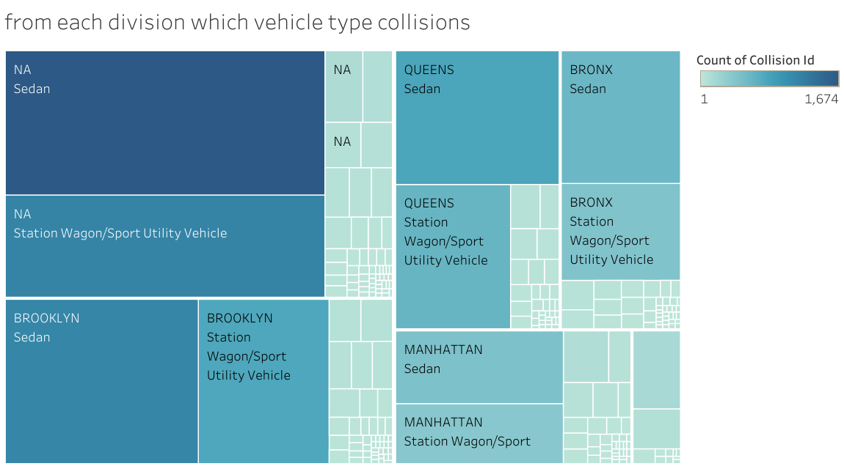

2. According to the data representation,

overall sport utility vehicle for highest collisions compared to other vehicles

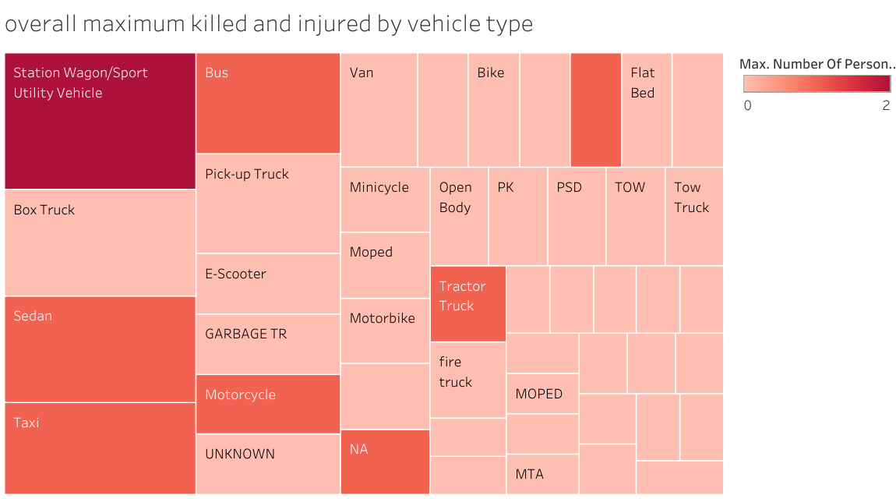

3. If we see the above representation to know the Reasons for contributing factor has the highest max injured and killed persons

i. Mostly alcohol involvement, unsafe speed, and inexperience are the cases for death of the persons

ii. mostly driver distraction, failure to yield right of way and following too closely are the cases for injured of the persons

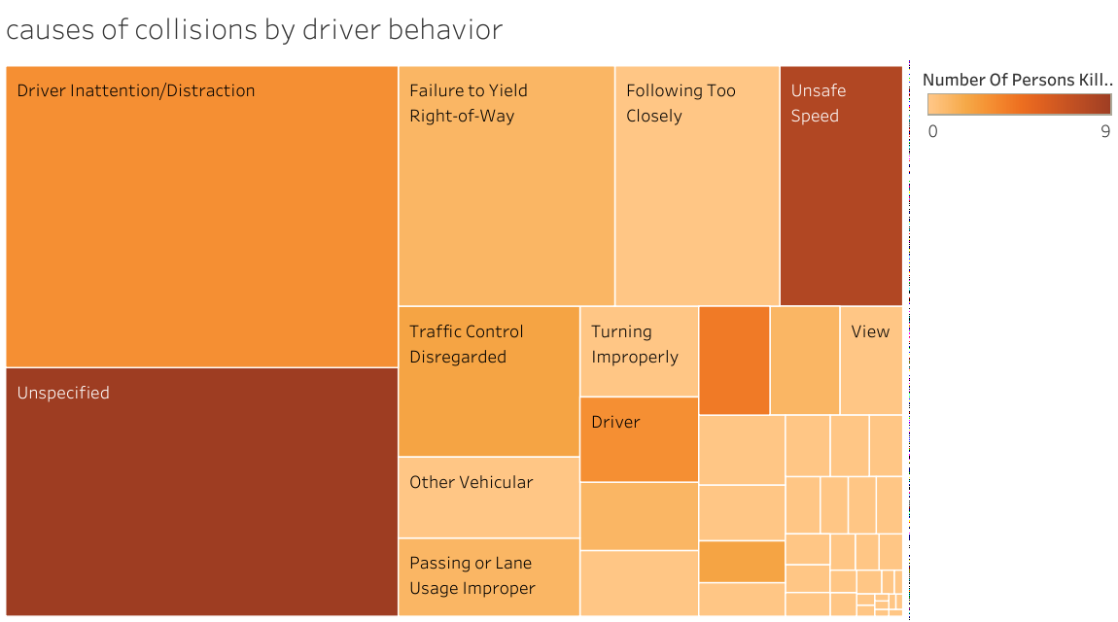

4. In this representation,

co-related borough, vehicle type, and contributing factor to know at what particular place what collisions are occurred by which vehicle and driver behaviour

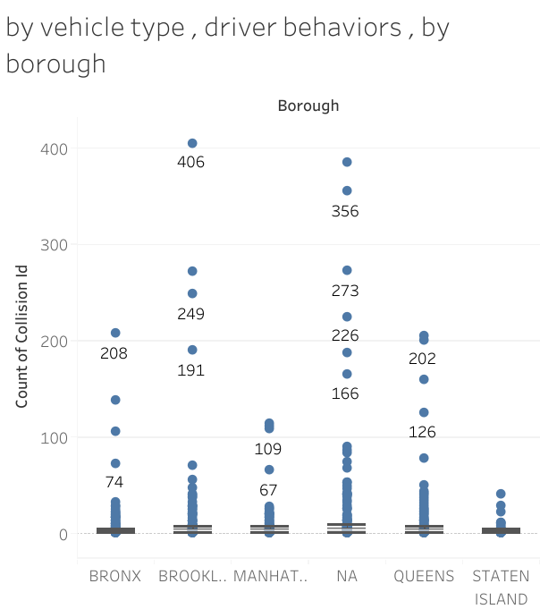

5. if we take a look

Bronx is the one of the divisions has recorded for many injured and killed accidents

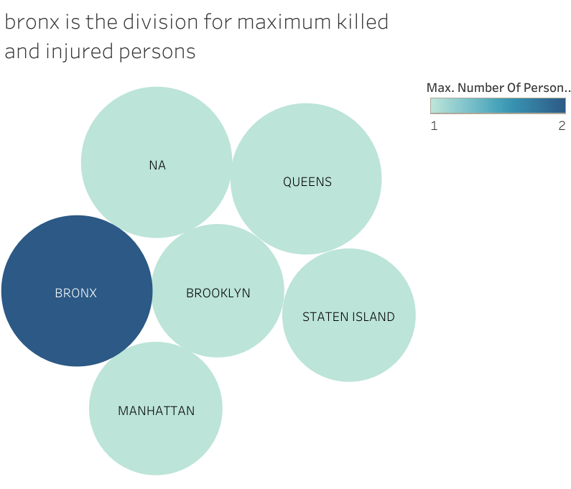

6. We can observe that, 17.00 is the time with maximum collision id records has been reported

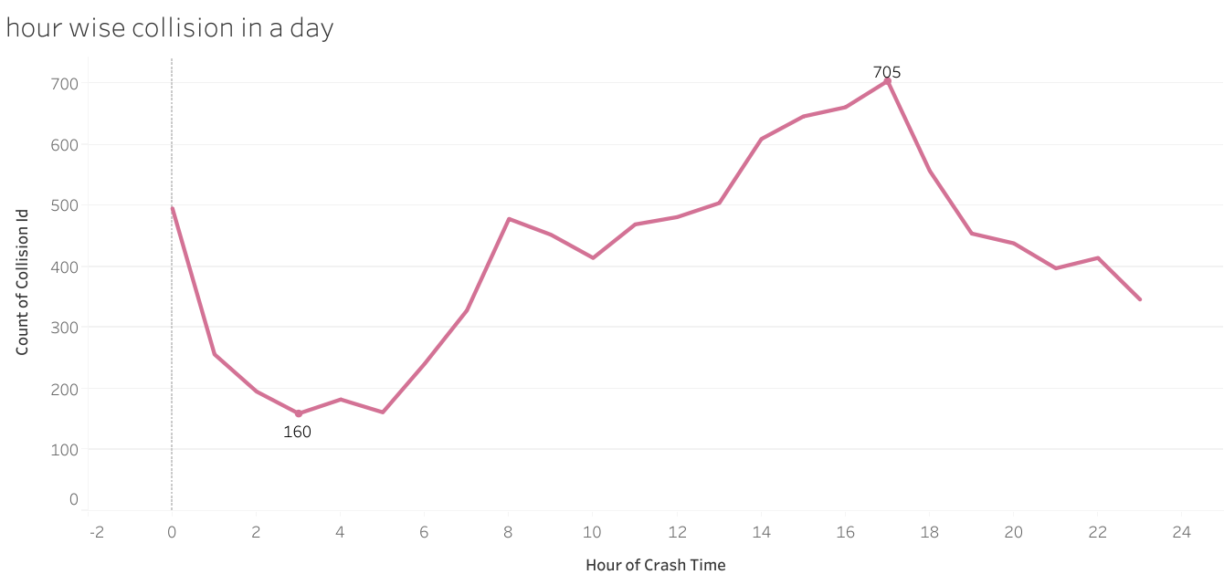

7. If we take look, the bar graph tells that maximum in the weekends (Saturday and Sunday) there are more Collisions

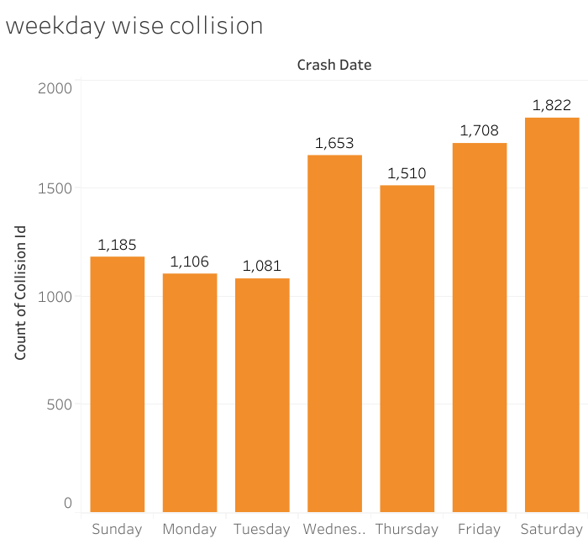

8. The visualization represents that in the month of April there was more collisions are been recorded

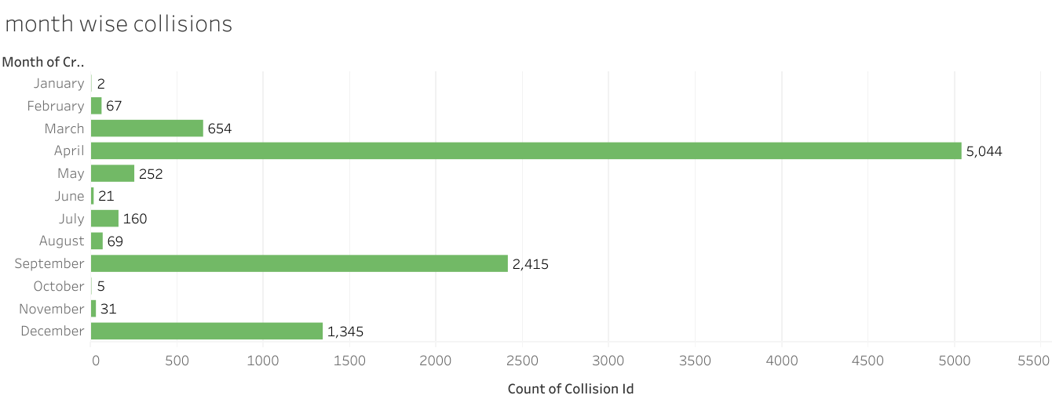

9. The above chart is the comparison of year

1. the first highest is the 2021 was total number of collisions as occurred
2. second highest is the 2022 was the total collision were taken place
3. in the year 2020 was the total collision has taken place

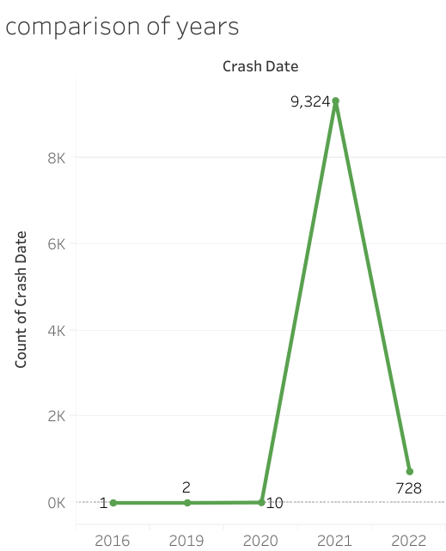

Dashboard

<https://public.tableau.com/app/profile/usha.vootla/viz/1_dashboardofvehiclecollision_16928144846090/Dashboard1>

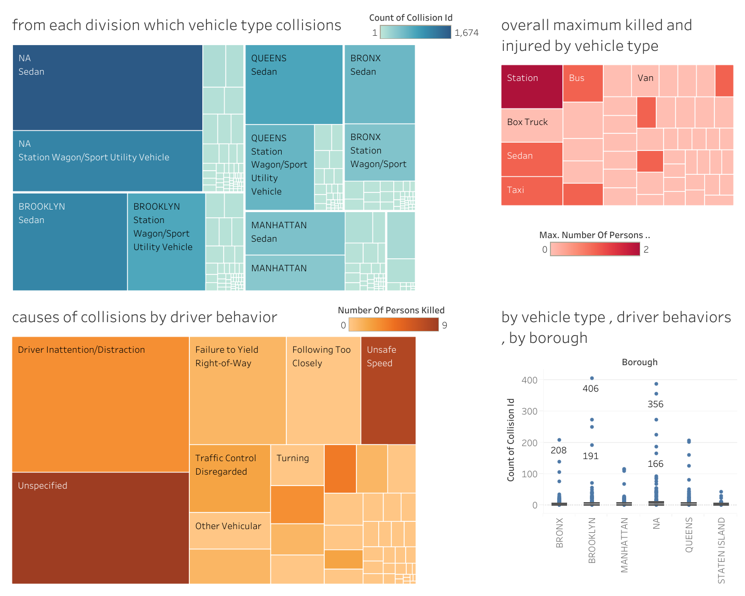

<https://public.tableau.com/app/profile/usha.vootla/viz/2_dashboardofvehiclecollisiondataset/Dashboard2>

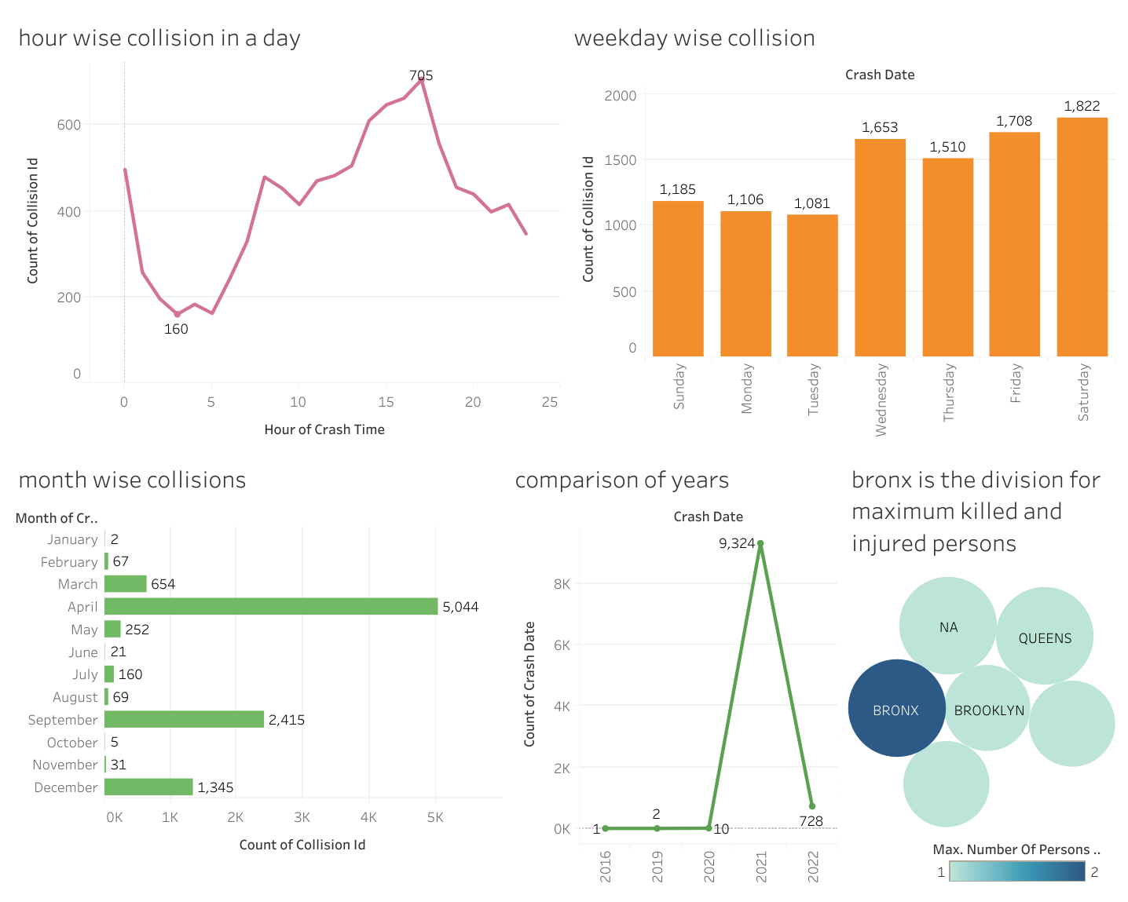

**conclusion**

finally, I want to conclude that in the year 2021 there was the huge collisions were recorded and Bronx is the division where it is the highest for collisions in addition driver distraction and unsafe speed is the contributing factor for more collisions and it this also includes sport utility vehicle and station wagon vehicle is recorded for highest collisions so, even if we look into data visualization, we get to know that at 5pm there is maximum collisions has been happening and that too in weekends

. according to my analysis 5pm is the time where parents will pick their Children from their schools in addition even in the cooperate world many company workers will leave at that time

As well at weekends many people will take a trip of their personal life and government should take some precautions on day basis to avoid collisions